**Team Name : Enigma Hunters**

**PS ID : KVH-014**

**PS TITLE : Chat Messenger Decryption Tool**

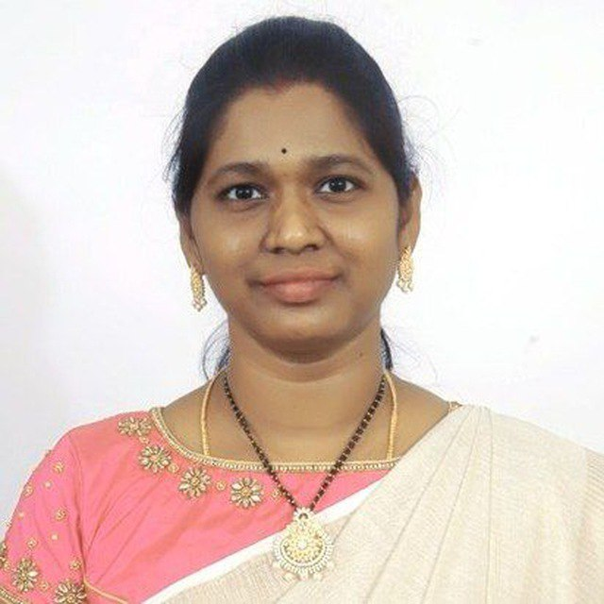

Dr. Radhika Rani Chintala (Mentor) Durjoy Majumdar (Team Leader)

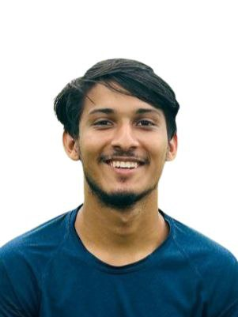

Asadar Zaman Nabin Anuj Kandel Sharma Sambandha Bhattarai

Jakka Shirini Mundra Lakshmiprasanna